title title example template example template title title title title title title title title
R.E. Doe,Wang Xxxxx and T.B. Jones

abstract
All papers should have an abstract that includes brief background, major objective, methods and major results. All paragraphs should be justified as illustrated. The length of the abstract should be limited to approximately 400 words.
Keywords: Dredging, beneficial uses, Environmental dredging, Ecological dredging.

introduction
The text should be single-spaced. The text is to be typed in 10 point using the font Times New Roman. Text text text text text text text. Text is justified. SI units must be used. Text text text text text text text text text text text text text text text text text text text text text.

Sub Heading
Text text text text text text text. All papers should have a Summary or Conclusions section. All references should be listed in alphabetical order in the Reference section.
(1)
Text text text text text text text text text text text text text text text text text text text text text text text text text text text text text text text.

Sub-Sub Heading
Text text text text text text text text text text text text text text text text text. Text text text text text text text text text text text text text text text text text text text text text text text text text text text text text text as shown in Figure 1.

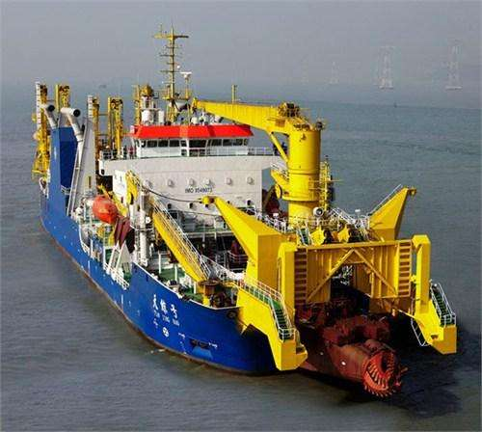
Figure 1. Descriptive title for figure.

Text text text text text text text text text text text text text text text text text (Jones et al. 1986). Text text text text text text text text text text text text text text text text text text text text text text text text text text text text text text text.

heading
Text text text text text text text text text text text text text text text text text text text text text text text text text text text text text text text.
Text text text text text text text text text text text text text text text text text. Text text text text text text text text text text text text text text text text text text text text text text text text text text text text text text text.

Sub Heading
Text text text text text text text text text text text text text text text text text text text text text text text text text text text text text text text ,as tabulated in Table 1.
Table 1. Descriptive title of table.

Text text text text text text text text text text text text text text text text text. Text text text text text text text text text text text text text text text text text text text text text text text text text text text text text text text.
(2)
Text text text text text text text text text text text text text text text text text text text text text text text text text text text text text text text.

Sub-Sub Heading
Text text text text text text text text text text text text text text text text text. Text text text text text text text text text text text text text text text text text text text text text text text text text text text text text text text.

conclusions
Text text text text text text text text text text text text text text text text text. Text text text text text text text text text text text text text text text text text text text text text text text text text text text text text text text.

references
Hunt, J.B. (2011). Environmental Dredging. New York: Smith & Son, Inc.
Jones, F., Doe, A., Hart, E.J.E., and Next, J.P.J. (1995). “The design of dredged material disposal sites.” Proceedings XIVth World Dredging Congress 1995, CEDA, Amsterdam, The Netherlands, 350-368.
White, F.K. and Jones, J.M. (2014). “The analysis of flow fields around dragheads.” Journal of Waterway, Port, Coastal and Ocean Engineering, 121 (5), ASCE, 1-16.
倪福生,韩玉红,顾磊,蒋爽(2010). “管道水力输送水平弯局部阻力实验研究” Experiment research on the local losses of bends in the hydraulic transport pipeline 2010,中国疏浚协会,第十九届世界疏浚大会论文集,中国,363-369.

CITATION
Doe, R.E., Wang Xxxxxx, X.Y., and Jones, T.B. “Title title title,” Proceedings of the Twenty- Second World Dredging Congress, WODCON XXII, Shanghai, CHINA, April 25-29, 2019.
倪福生,韩玉红,顾磊, 蒋爽(2010). “管道水力输送水平弯局部阻力实验研究” Experiment research on the local losses of bends in the hydraulic transport pipeline 2010,中国疏浚协会,第十九届世界疏浚大会论文集,中国,363-369.

ACKNOWLEDGEMENTS
Text text text text text text text text text text text text text text text text text. Text text text text text text text text text text text text text text text text text text text text text text text text text text text text text text text.

NOMENCATURE
All symbols should be defined in the text where the symbol is first mentioned. It is up to the author to determine if the use of symbols in the manuscript warrants a nomenclature table. If necessary, insert a two column table and list symbol and units in one column and the definition in the second column.

Engineer, XYZ Company, 1215 North Street, Cleveland, Ohio 61456, USA, T: 216-456-5896, Email: redoe@xxxxx.com.
Position Title, Company Name, Address, City, State, Postal Code, Country, telephone, email.
Position Title, Company Name, Address, City, State, Postal Code, Country, telephone, email.

